http://www.byrdseed.com/images/rules-32.gif

Describe the importance of the 3 types of art in West Africa.

* Griots
* Proverbs
* Kente

African Historical and Artistic Traditions Use Pages 147-151



Support or refute the

following statement made by

many historians, “to be ‘civilized’ a culture must have a written language.

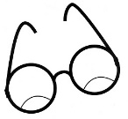

Infer: In what ways might the views of writers like Ibn Battutah differed from the views of West African griots?