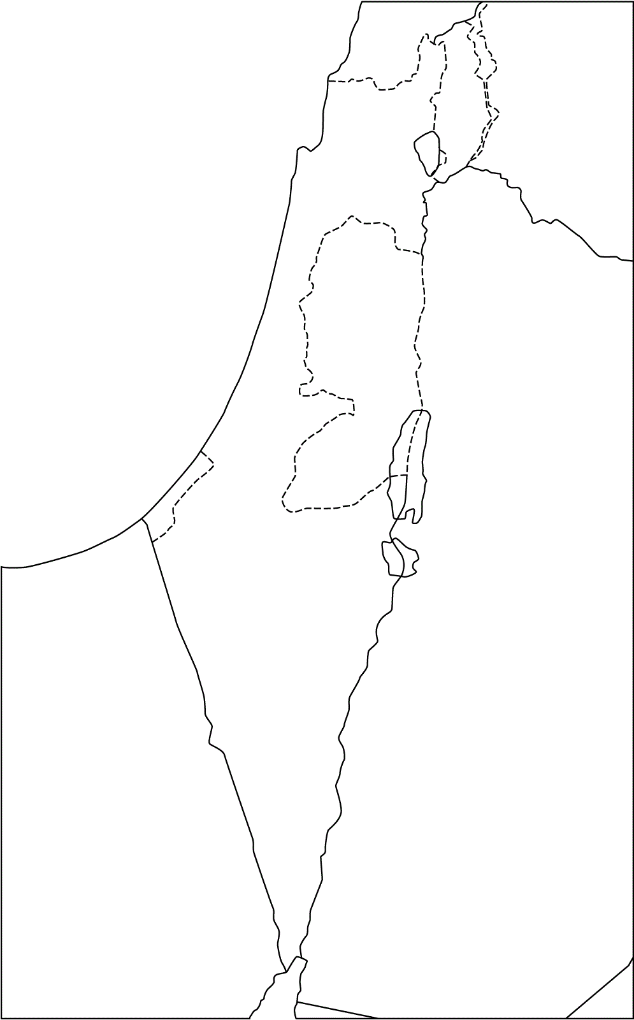
Ancient Israel Geography
Directions: Watch the video attached to http://www.mrisaacsclass.com/current-work.html for Tuesday (you will need to watch it several times). Label the following while watching the video:
Coastal plain, Central Mountains, Jordan River, Sea of Galilee, Dead Sea, Mediterranean Sea, Mount Hermon, Jerusalem.

Geography
Economy
Political
While watching and rewatching the video, give at least 2 facts about each of the traits of civilization listed.

