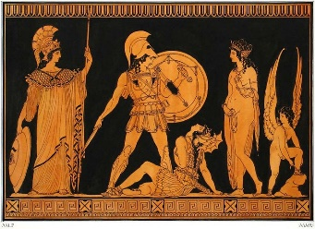 | This piece of art is from the _________________________ era because ________________________________________________________________________________________________________________________  ____________________________________________________________  ____________________________________________________________
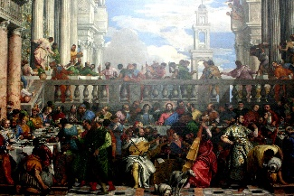 | This piece of art is from the _________________________ era because ____________________________________________________________  ____________________________________________________________  ____________________________________________________________  ____________________________________________________________
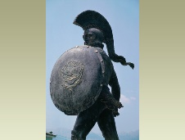 | This piece of art is from the _________________________ era because ____________________________________________________________  ____________________________________________________________  ____________________________________________________________  ____________________________________________________________
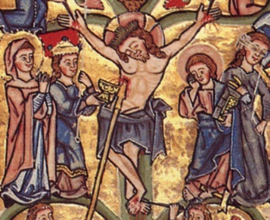 | This piece of art is from the _________________________ era because ____________________________________________________________  ____________________________________________________________  ____________________________________________________________  ____________________________________________________________
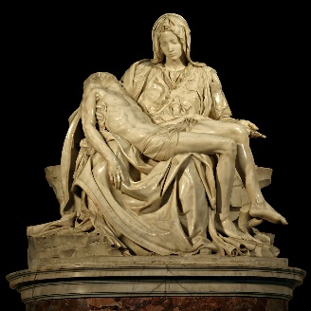 | This piece of art is from the ______________________ ___era because ____________________________________________________________  ____________________________________________________________  ____________________________________________________________  ____________________________________________________________  ____________________________________________________________  ____________________________________________________________
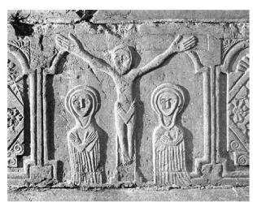 | This piece of art is from the ______________________ era because ____________________________________________________________  ____________________________________________________________  ____________________________________________________________  ____________________________________________________________  ____________________________________________________________
Categorize the following pieces of art by era.

