Empire | Ghana | Mali
Location | 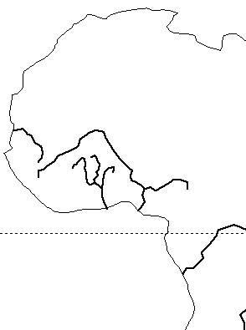
Cities
Leader
Empire | Ghana | Mali
Religion
Economy
Reasons for its fall.

