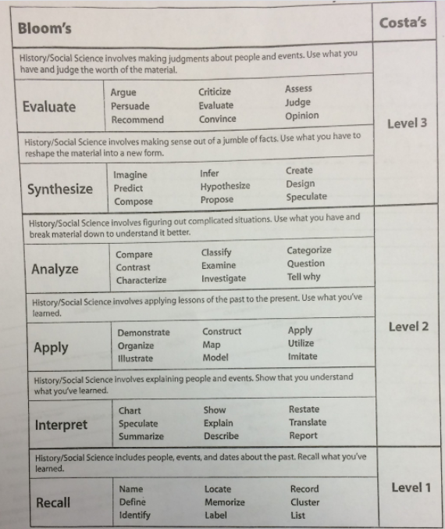
Checklist:
- Highlight the essential question in Yellow
- Underline key terms
- Highlight the main ideas in green
- Highlight the three or four most important details in pink
- Add 3 questions at least one of them should be a level 2 question
- Finish with a well written summary of the notes.

