Events Leading Up to the Crusades | The Crusades  1095-1291  A series of wars by European Christians against Muslims over Palestine & nearby lands that later expanded to campaigns against Jews and Christian heretics in Europe, North Africa, & the Middle East. | Impact on Christians | + | -
_______________________________________________________
_______________________________________________________
_______________________________________________________
_______________________________________________________
_______________________________________________________
_______________________________________________________
_______________________________________________________
_______________________________________________________
_______________________________________________________
_______________________________________________________
_______________________________________________________
_______________________________________________________
_______________________________________________________
_______________________________________________________
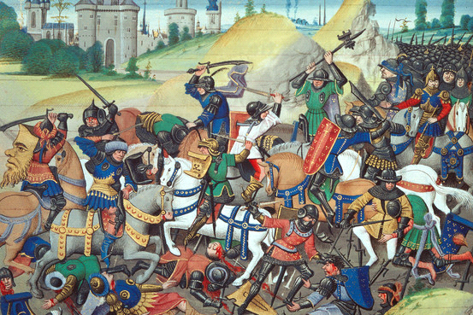_______________________________________________________
 |  | Impact on Muslims | + | -
 |  | Impact on Jews | + | -

