/OBJECTIVE:_____Jewish Beliefs_______________ |  | NAME: ____________________________  Block:______ DATE:________________
ESSENTIAL QUESTION:____________________________________________________________________
QUESTIONS:  __________________________  __________________________  __________________________  __________________________  __________________________  __________________________  __________________________  __________________________  __________________________  __________________________  __________________________  __________________________  __________________________  __________________________  __________________________  __________________________  __________________________  __________________________  __________________________  __________________________  __________________________ | 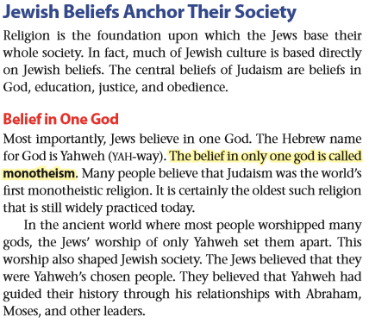  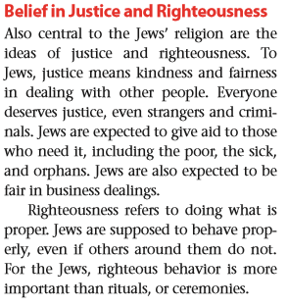  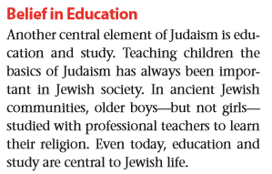
SUMMARY:_______________________________________________________________________________
_______________________________________________________________________________________
_______________________________________________________________________________________
_______________________________________________________________________________________
/OBJECTIVE:_____Jewish Beliefs_______________ |  | NAME: ____________________________  Block:______ DATE:________________
ESSENTIAL QUESTION:____________________________________________________________________
QUESTIONS:  __________________________  __________________________  __________________________  __________________________  __________________________  __________________________  __________________________  __________________________  __________________________  __________________________  __________________________  __________________________  __________________________  __________________________  __________________________  __________________________  __________________________  __________________________  __________________________  __________________________  __________________________ | 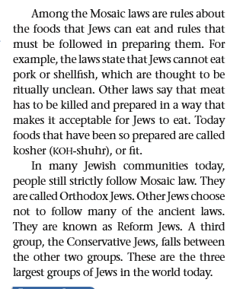  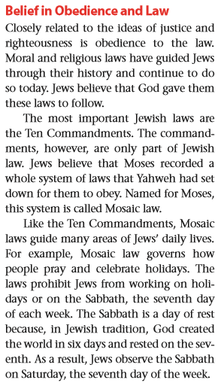
SUMMARY:_______________________________________________________________________________
_______________________________________________________________________________________
_______________________________________________________________________________________
_______________________________________________________________________________________

/OBJECTIVE:_____Jewish Texts_______________ |  | NAME: ____________________________  Block:______ DATE:________________
ESSENTIAL QUESTION:____________________________________________________________________
QUESTIONS:  __________________________  __________________________  __________________________  __________________________  __________________________  __________________________  __________________________  __________________________  __________________________  __________________________  __________________________  __________________________  __________________________  __________________________  __________________________  __________________________  __________________________  __________________________  __________________________  __________________________  __________________________ | 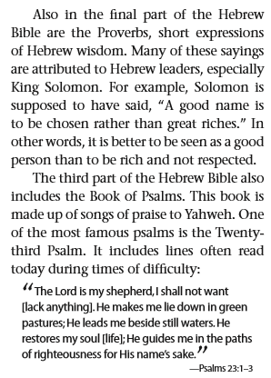  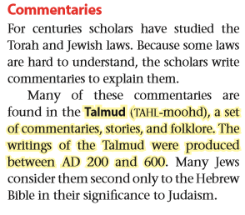  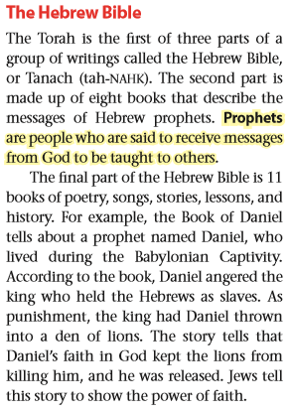  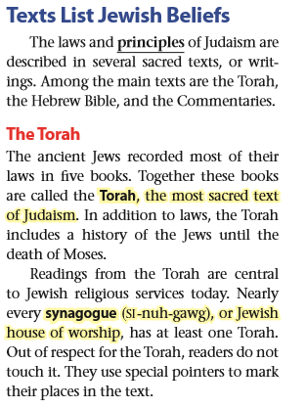
SUMMARY:_______________________________________________________________________________
_______________________________________________________________________________________
_______________________________________________________________________________________
_______________________________________________________________________________________
Output
_______________________________________________________________________________________
_______________________________________________________________________________________
_______________________________________________________________________________________
_______________________________________________________________________________________
_______________________________________________________________________________________
_______________________________________________________________________________________
_______________________________________________________________________________________
_______________________________________________________________________________________
_______________________________________________________________________________________
_______________________________________________________________________________________
_______________________________________________________________________________________
Beliefs of Judaism
_______________________________________________________________________________________
_______________________________________________________________________________________
_______________________________________________________________________________________
_______________________________________________________________________________________
_______________________________________________________________________________________
_______________________________________________________________________________________
_______________________________________________________________________________________
_______________________________________________________________________________________
_______________________________________________________________________________________
_______________________________________________________________________________________
_______________________________________________________________________________________
_______________________________________________________________________________________
_______________________________________________________________________________________
__2 connections:_____________________________________________________________________
_______________________________________________________________________________________
_______________________________________________________________________________________
_______________________________________________________________________________________
Output: Provide neat work (1) ___ Use your creativity to demonstrate what you have learned in the input: use colorful illustrations with captions, charts, short paragraphs (2) ____ Include connections to self, world, text…., point of view (2) ____.

