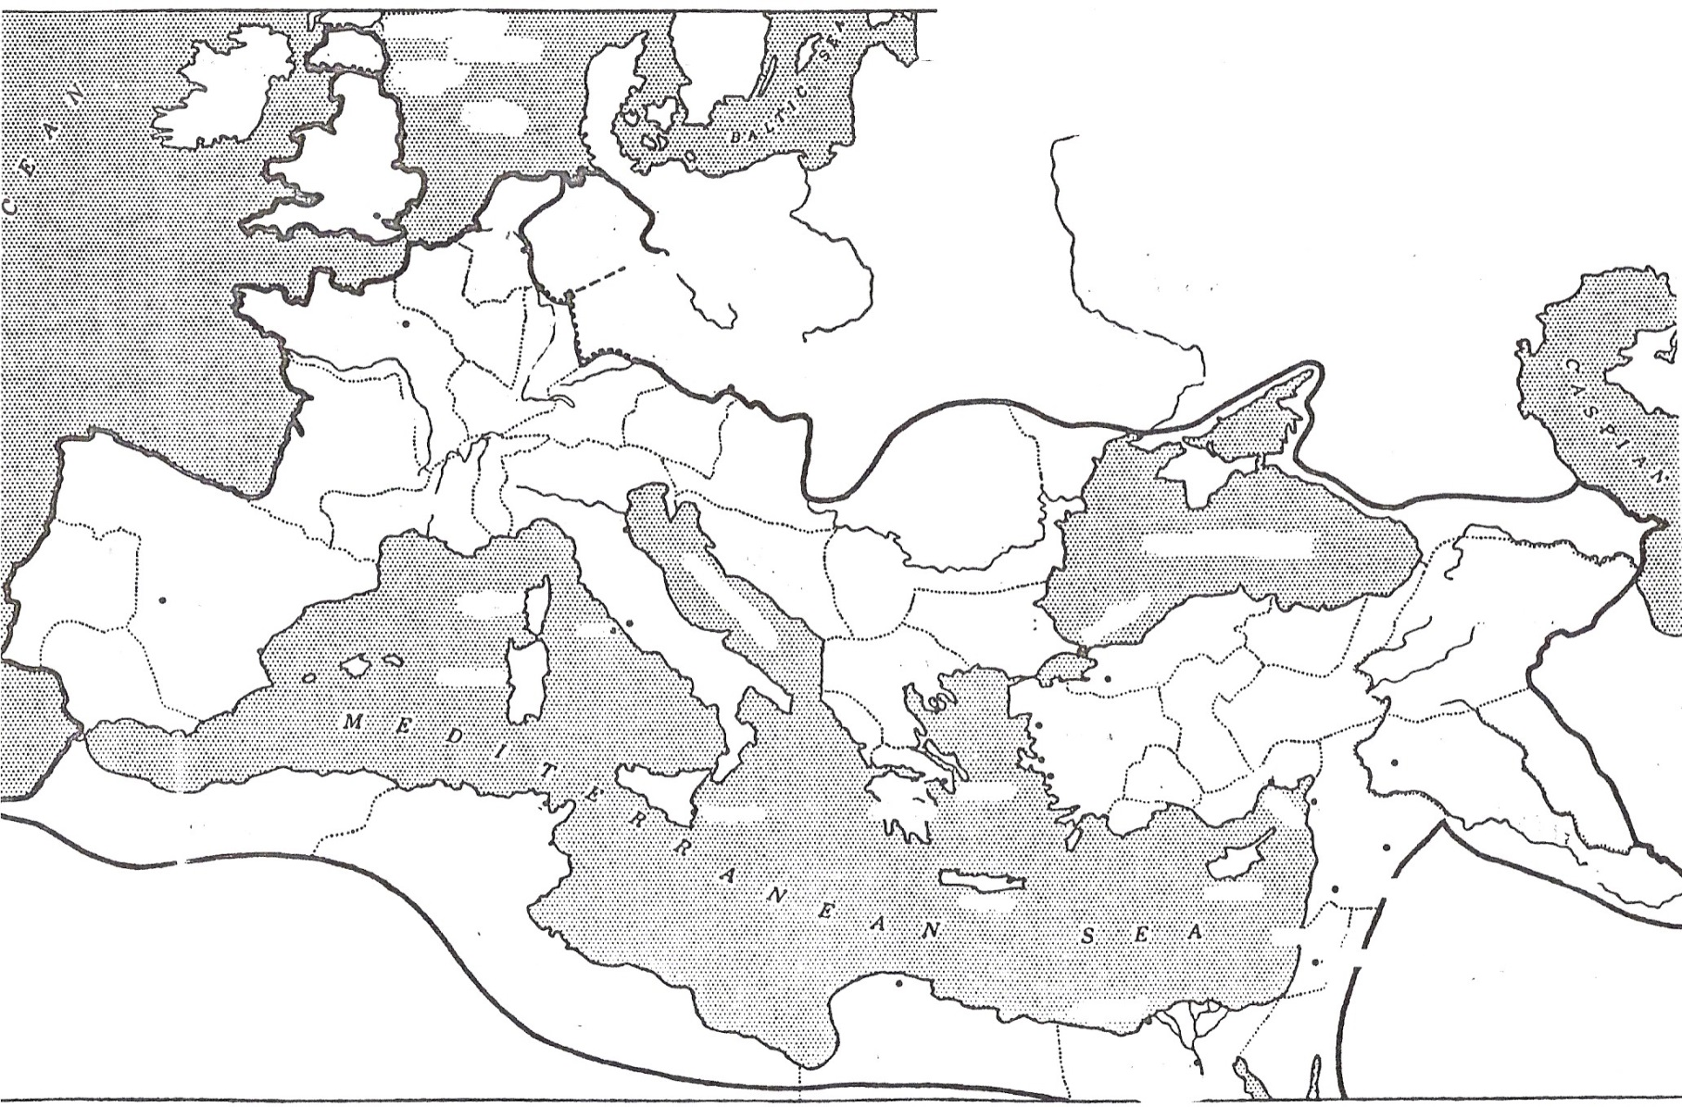
The Roman Empire at its’ Height, 117 AD

