Trait | Definition | Related words | TPR
Geography | the study of the physical features of the earth and its atmosphere, and of human activity as it affects and is affected by these, including the distribution of populations and resources, land use, and industries. | Geographic features,  Physical features, maps, cartographer
Political  Structure | relating to the power of government and how it works. | Civics, government, rulers, military, king, emperor, etc…  Laws
Economic | a science concerned with the process or system by which goods and services are produced, sold, and traded | Money, jobs, trading, industry, buying, selling, production.
Religion | a belief in and worship of a controlling power, especially a personal God or gods. Organized around ceremonies and rules for worship. | gods, priests, temples, churches, after-life, spiritual
Social Structure | social organization based on established patterns of social interaction between different relationships (between parents and children, bosses and workers, etc.) of a particular society. | Social hierarchy, class | 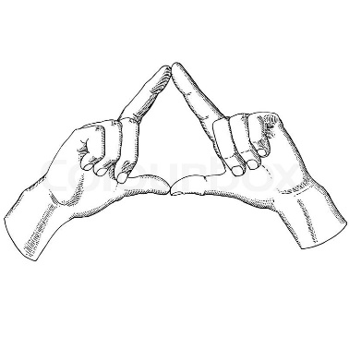
Traits of Civilization

